**LoRa Enhanced Real-Time Earthquake Monitoring System for Constructions Using IoT and Cloud**

**1. Abstract:**

Earthquake disasters, perennial threats to civilizations, have spurred the evolution of advanced monitoring and detection systems. In ancient times, seismic detection relied on seismometers and geophones, but the contemporary landscape demands innovative solutions for real-time monitoring, impact mitigation, and early detection. The multifaceted impacts of earthquakes, from structural damage to potential loss of life, necessitate a proactive approach to protect livelihoods and ensure efficient rescue operations. This project introduces the "LoRa Enhanced Real-Time Earthquake Monitoring System for Constructions Using IoT and Cloud," departing from historical seismic detection approaches by leveraging seismic sensors for swift identification of seismic activities. The system's effectiveness lies in its ability to detect and monitor earthquakes in real-time. Strategically deployed seismic sensors promptly capture ground movements, and through LoRa communication, the acquired data is swiftly transmitted to a cloud-based platform for comprehensive analysis. This facilitates informed decision-making, enhancing overall responsiveness to seismic events. Preventive measures and cautions are integral to earthquake disaster management, and this project integrates advanced seismic sensors with real-time cloud data analysis, enabling timely evacuation alerts, structural reinforcements, and emergency response coordination.

**2. Introduction:**

This project combines seismic sensing technology, IoT, and cloud analytics to address the limitations of traditional earthquake monitoring systems, such as the high cost and limited access to seismometers. It uses a range of seismic sensors like accelerometers, gyroscopes, tilt sensors, vibration sensors, and piezoelectric sensors, all managed by the ESP32 microcontroller for efficient data processing and transmission. The LoRaWAN communication protocol is employed for its long range, low power use, and adaptability, outperforming Bluetooth and Wi-Fi. LoRaWAN enables reliable data transmission, even in remote construction areas. A cloud-based platform is used to collect, store, and analyze seismic data in real time, ensuring efficient management and visualization.

**3. Proposed Work:**

In the proposed system, two distinct architectures are implemented: the Single Node System Architecture and the Overall Network System Architecture. The Single Node System Architecture involves the creation of a singular node. In this setup, the integrated sensors within the designated node transmit data to the LoRa receiver through the LoRa transmitter. This configuration ensures that data from the specific node is efficiently communicated to the central monitoring system. Contrastingly, the Overall Network System Architecture accommodates the deployment of multiple nodes within a construction site. In this scenario, each node is equipped with sensors capable of collecting data related to environmental parameters, particularly seismic activity. Every node employs its dedicated LoRa transmitter to relay the collected data to the central LoRa receiver. The central LoRa receiver acts as a hub, gathering data from all nodes within the network. Subsequently, this compiled data is transmitted to the cloud for storage and analysis with the assistance of the ESP32 microcontroller. This cloud-based storage ensures a centralized repository for all seismic data collected from various nodes across the construction site. This dual architecture approach allows for adaptability to specific needs. The Single Node System Architecture caters to scenarios where a focused observation point is sufficient, while the Overall Network System Architecture facilitates broader coverage by enabling multiple nodes to contribute seismic data, fostering a comprehensive understanding of seismic activity across the construction site.

**3.1. Block Diagram:**

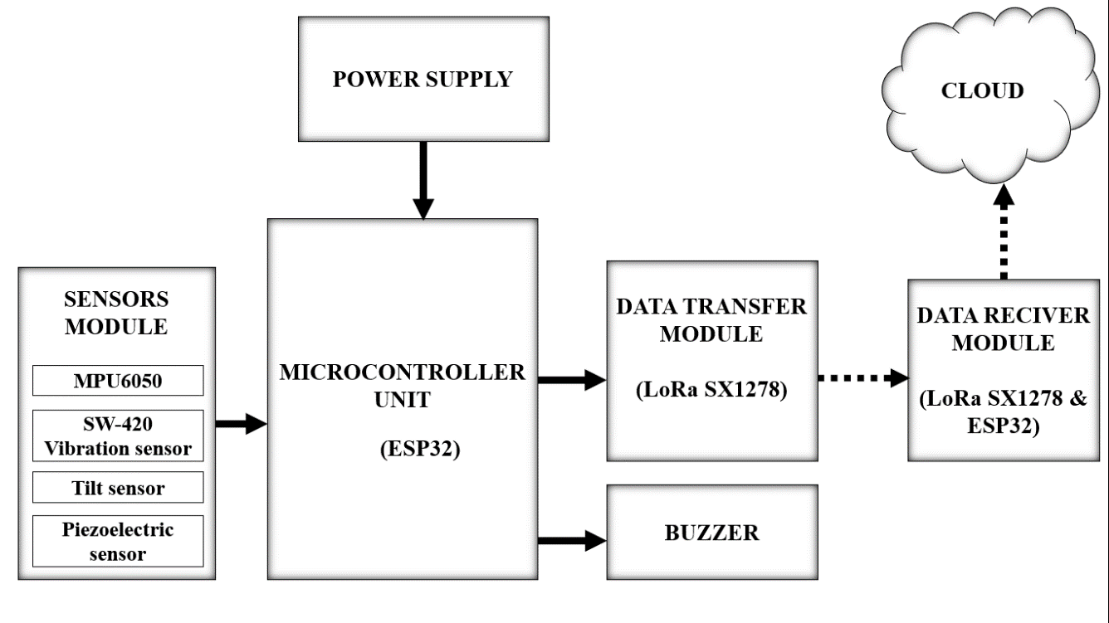

The block diagram outlines the complex architecture of the system featuring four essential blocks for precise seismic data acquisition, processing, and real-time transmission. The Sensor Module integrates advanced seismic sensors like the MPU6050 accelerometer, gyroscope, SW-420 vibration sensor, tilt sensor, and piezoelectric sensor, operating in synergy to continuously monitor ground vibrations and structural movements. The ESP32 microcontroller serves as the central processing unit, handling real-time data from the Sensor Module and playing a vital role in decision-making and alert generation. The Data Transmission and Data Receiver Unit utilize the SX1278 LoRa module for seamless and reliable data transmission to the central LoRa receiver, employing the LoRaWAN protocol for optimal efficiency.

**3.2 Flow Diagram:**

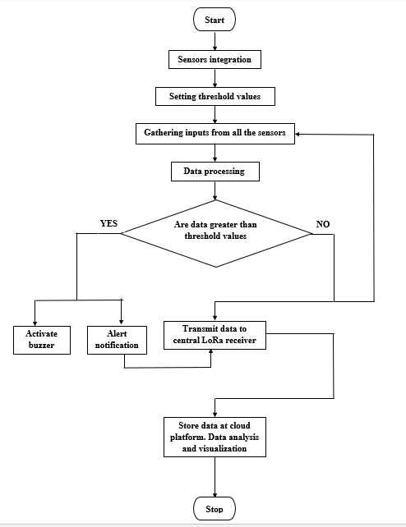

The operational sequence of the system unfolds with the provision of power to initiate the ESP32 microcontroller's functions. The integration of sensors with the MCU follows, each sensor utilizing its corresponding pins and drawing power for operation. These sensors continuously generate output values influenced by environmental conditions at the construction site. To identify seismic events, specific threshold values are defined for each sensor, and their output data is systematically collected. The ESP32 microcontroller assumes the crucial role of processing this data, scrutinizing whether it surpasses the predefined threshold values. Upon detection of seismic activity exceeding the set thresholds, the system triggers an alert mechanism, activating a buzzer. Simultaneously, it transmits timely alerts containing earthquake location information to the central LoRa receiver. This alert mechanism serves to notify rescue teams promptly, facilitating swift assistance to injured individuals at the construction site. Once the earthquake situation is resolved, the monitoring process ceases, and the accumulated data is securely stored in the cloud. In instances where the data does not exceed the predefined thresholds, it undergoes transmission to the central LoRa receiver for continuous monitoring. The data transmitted to the receiver is seamlessly stored in the cloud using the ESP32 microcontroller's built-in Wi-Fi functionality, thereby completing the comprehensive workflow of the earthquake monitoring system. This orchestrated process ensures timely and effective responses to seismic events, contributing to enhanced safety and disaster mitigation in construction environments.

**3.3 Single Node System Architecture:**

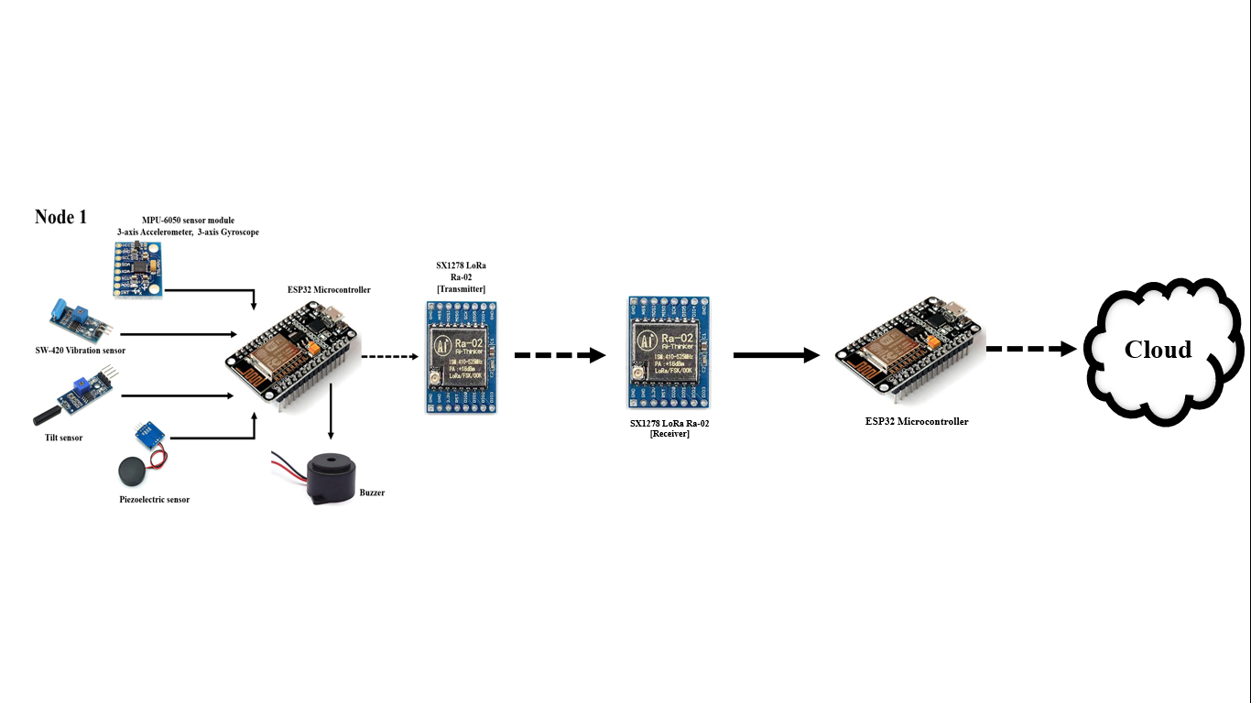

This node integrates advanced seismic sensors, including the MPU6050 (with a 3-axis accelerometer and gyroscope), SW-420 vibration sensor, tilt sensor, and piezoelectric sensor. These sensors establish a cohesive network connected intricately to the ESP32 microcontroller for efficient data acquisition. The ESP32 processes the data comprehensively, employing a "threshold-based detection" mechanism to evaluate sensor values against predefined thresholds. If values fall below the threshold, the microcontroller retains the data; if they surpass the threshold, indicating a seismic event, it triggers a buzzer for immediate audible notification and dispatches alerts to the rescue team. The LoRa advanced communication protocol ensures swift notification during earthquakes, with two LoRa modules facilitating seamless data transmission between sensors and the microcontroller. Collected data, including sensor values and alerts, is stored in the cloud via the ESP32 microcontroller, enabling in-depth analysis and data visualization for a comprehensive understanding of seismic events. This integrated approach underscores the system's efficacy in providing real-time alerts, ensuring safety, and fostering advanced data analysis for enhanced earthquake monitoring.

**3.4 Overall Network Architecture:**

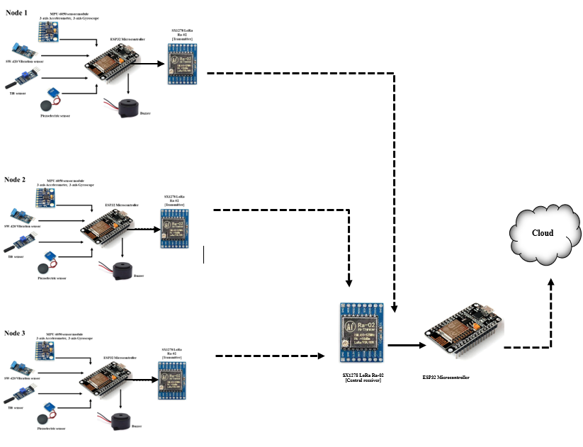

The Overall Network System Architecture demonstrates the scalability of the seismic monitoring system, supporting "n" nodes across construction sites. Each node replicates the Single Node System, equipped with advanced seismic sensors like MPU6050, SW-420 vibration sensor, tilt sensor, and piezoelectric sensor, all connected to the ESP32 microcontroller. These nodes operate independently, continuously collecting and transmitting seismic data to the central LoRa receiver using the LoRa communication protocol. The central receiver consolidates data from all nodes, which is then stored in the cloud via ESP32, enabling centralized analysis and visualization of seismic events. The architecture accommodates multiple nodes, from Node 1 to Node N, ensuring scalability and adaptability to diverse environments. Each node mirrors Node 1, which includes the ESP32, sensors, a buzzer for alerts, and a LoRa module for data transmission. LoRa modules at each node ensure efficient communication with the central receiver, using time division multiplexing for synchronized transmission. The cloud platform stores and processes data from all nodes, offering real-time analysis and insights through user-friendly dashboards. Key optimization strategies include sensor calibration, time division multiplexing, and threshold-based algorithms for precise earthquake detection. The system's cloud infrastructure handles large volumes of data efficiently, while continuous testing ensures accurate detection of seismic activity. The network architecture provides a reliable, scalable, and responsive solution for real-time earthquake monitoring, adaptable to various construction site conditions.

**4. Overall Implementations:**

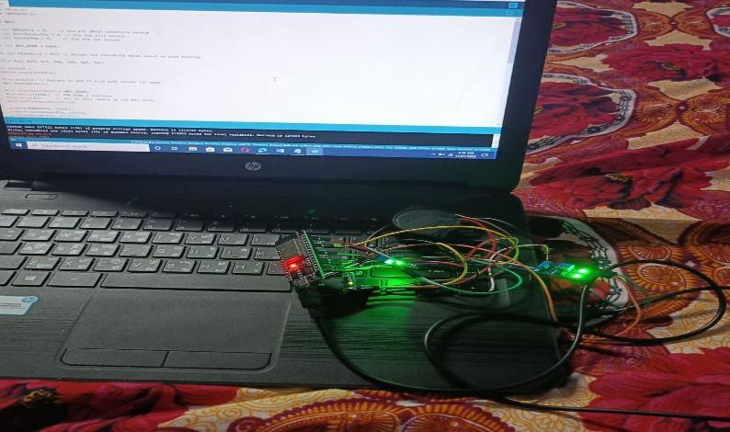

The sensor module, consisting of the MPU6050 accelerometer and gyroscope, SW-420 vibration sensor, tilt sensor, and piezoelectric sensor, is intricately connected to the ESP32 microcontroller, forming the foundation of the system. Additionally, a buzzer is seamlessly integrated to provide real-time audible notifications during seismic events. The LoRa communication setup employs the SX1278 LoRa module for efficient long-range wireless communication, linking the LoRa transmitter to the ESP32 at the transmitter side and the LoRa receiver at the receiver side, enabling data transmission to the central LoRa receiver. Software development utilizing the Arduino IDE focuses on real-time data processing, implementing a threshold-based detection mechanism, and activating the buzzer in response to seismic activity. Configuration of LoRaWAN communication protocols ensures seamless and reliable data transmission. Cloud integration involves establishing an IoT cloud platform, leveraging platforms to serve as a centralized repository.

**5. Results:**

**5.1. Real-time data without earthquake alert:**

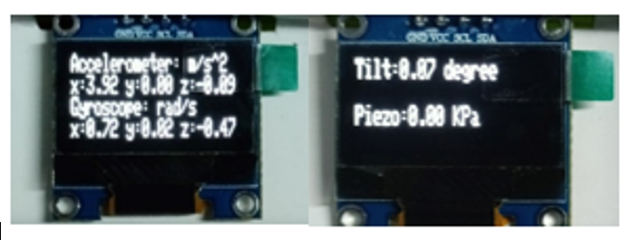

**5.2 Real-time data with earthquake alert:**

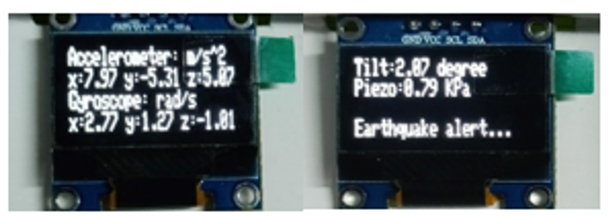

**6. Conclusion and Future work:**

In conclusion, the LoRa-enhanced earthquake monitoring system signifies a significant advancement in construction site safety during seismic events. It leverages LoRaWAN communication protocols for robust real-time monitoring, incorporating highly sensitive sensors to acquire precise data on earthquakes. The integration of the LoRa module extends the system's reach for seamless long-distance data transmission. A key feature is the proactive alert mechanism, promptly notifying individuals and rescue teams during seismic activity to minimize impact. Integration with cloud-based technologies transforms data storage, analysis, and real-time monitoring, marking a paradigm shift in disaster management. The success of IoT and cloud technologies highlights their potential in safeguarding lives. The system's adaptability, from sensor data acquisition to LoRa communication, showcases its efficacy in real-world scenarios, laying the foundation for future disaster management developments. The LoRa-enhanced earthquake monitoring system emerges as a pioneering solution, emphasizing technology's transformative impact on community well-being in seismic-prone regions. In the future phases of the project, the focus will transition from basic output displays to advanced functionalities. This includes implementing LoRa-to-LoRa communication in the single-node system to enhance real-time data transmission efficiency. Further developments involve expanding the system to accommodate multiple nodes (N Number of Nodes) with synchronized data transmission using time division multiplexing. Additionally, a key initiative is the establishment of an IoT cloud platform, serving as a centralized hub for collecting, storing, organizing, analysing, and visualizing seismic data from different nodes.